Name: Majid Ali
CMS ID: 053-25-0017
Course: Computer Networking
Section: Software Engineering

LAB: 3
Part (A)
Enter filter tcp
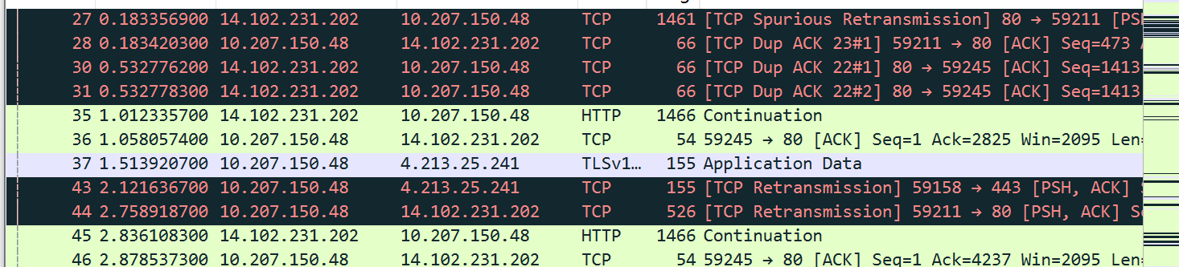

Filter HTTP Where GET request packet
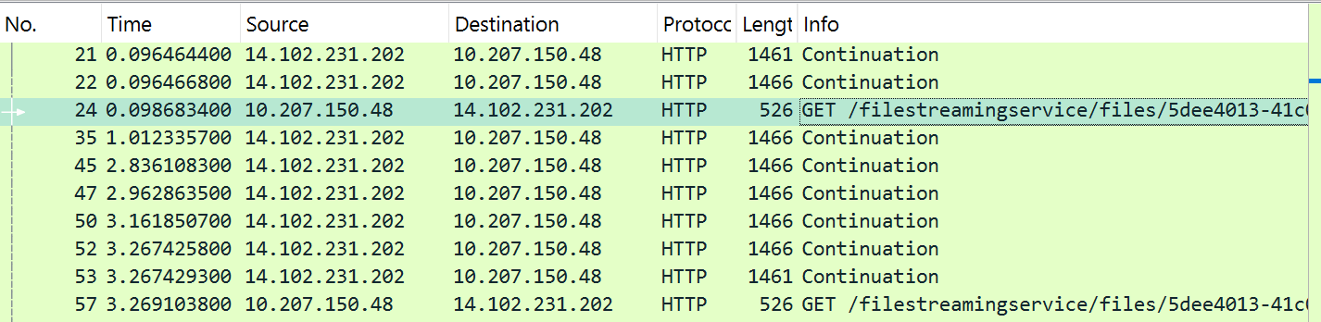
Now Check HTTP/1.1 200
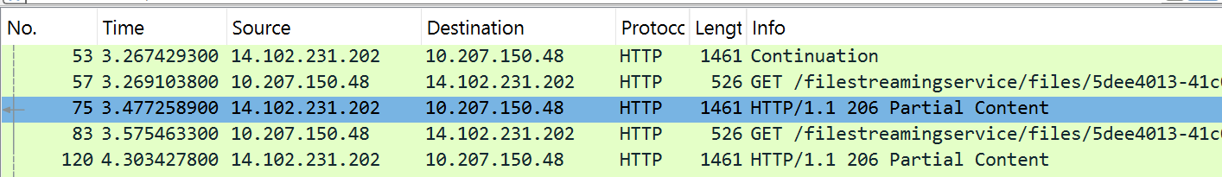

Calculation time difference between HTTP and HTTP/1.1 200
3.3785755

Check IP Address
Source Address: 10.207.150.48
Destination Address: 14.102.231.202

Check name of browser in panel HTP

Check Destination Port
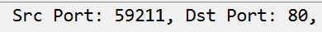

GET and OK print
